Permanente Evaluatie 1

Netwerk schema

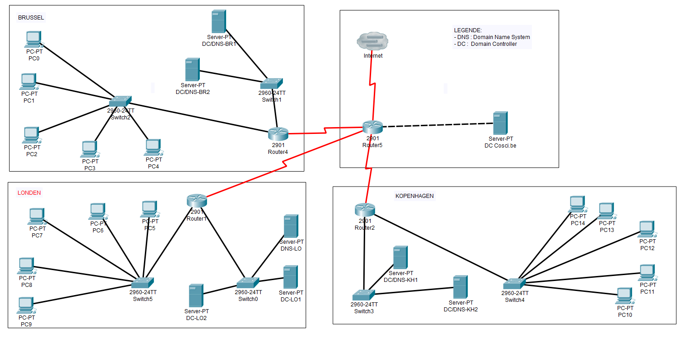

Active Directory schema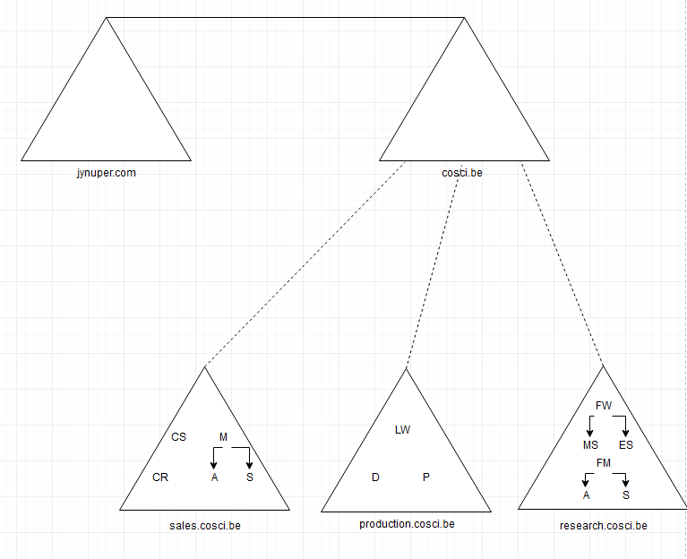

Overzicht IP – adressen

|  |  |  |  |  |
| --- | --- | --- | --- | --- |
| **Apparaat** | **IP-adres** | **Subnet-masks** | **Gateway** | **DNS-server** |
|
|  |  |  |  |  |
| **Brussel** |  |  |  |  |
| PC0 | 10.72.0.1 | 255.255.255.248 | 10.72.255.254 | 10.72.0.6 |
| PC1 | 10.72.0.2 | 255.255.255.248 | 10.72.255.254 | 10.72.0.6 |
| PC2 | 10.72.0.3 | 255.255.255.248 | 10.72.255.254 | 10.72.0.6 |
| PC3 | 10.72.0.4 | 255.255.255.248 | 10.72.255.254 | 10.72.0.6 |
| PC4 | 10.72.0.5 | 255.255.255.248 | 10.72.255.254 | 10.72.0.6 |
|  |  |  |  |  |
| DC/DNS-BR1 | 10.72.0.6 | 255.255.255.248 | 10.72.255.254 |  |
| DC/DNS-BR2 | 10.72.0.7 | 255.255.255.248 | 10.72.255.254 |  |
|  |  |  |  |  |
| Router4 | 10.72.255.253 | 255.255.255.248 |  | 10.72.0.6 |
|  | 10.72.255.254 | 255.255.255.248 |  | 10.72.0.6 |
|  |  |  |  |  |
| **London** |  |  |  |  |
| PC5 | 10.12.0.1 | 255.255.255.248 | 10.12.255.254 | 10.12.7.18 |
| PC6 | 10.12.0.2 | 255.255.255.248 | 10.12.255.254 | 10.12.7.18 |
| PC7 | 10.12.0.3 | 255.255.255.248 | 10.12.255.254 | 10.12.7.18 |
| PC8 | 10.12.0.4 | 255.255.255.248 | 10.12.255.254 | 10.12.7.18 |
| PC9 | 10.12.0.5 | 255.255.255.248 | 10.12.255.254 | 10.12.7.18 |
|  |  |  |  |  |
| DNS-LO | 10.12.7.18 | 255.255.255.248 | 10.12.255.254 |  |
| DC-LO1 | 10.12.0.8 | 255.255.255.248 | 10.12.255.254 |  |
| DC-LO2 | 10.12.0.9 | 255.255.255.248 | 10.12.255.254 |  |
|  |  |  |  |  |
| Router1 | 10.12.255.253 | 255.255.255.248 |  | 10.12.0.8 |
|  | 10.12.255.254 | 255.255.255.248 |  | 10.12.0.8 |
|  |  |  |  |  |
| **Kopenhagen** |  |  |  |  |
| PC10 | 172.16.0.2 | 255.255.255.248 | 172.16.0.1 | 172.16.0.8 |
| PC11 | 172.16.0.3 | 255.255.255.248 | 172.16.0.1 | 172.16.0.8 |
| PC12 | 172.16.0.4 | 255.255.255.248 | 172.16.0.1 | 172.16.0.8 |
| PC13 | 172.16.0.5 | 255.255.255.248 | 172.16.0.1 | 172.16.0.8 |
| PC14 | 172.16.0.6 | 255.255.255.248 | 172.16.0.1 | 172.16.0.8 |
|  |  |  |  |  |
| DC/DNS-KH1 | 172.16.0.8 | 255.255.255.248 | 172.16.0.1 |  |
| DC/DNS-KH2 | 172.16.0.9 | 255.255.255.248 | 172.16.0.1 |  |
|  |  |  |  |  |
| Router2 | 172.16.0.11 | 255.255.255.248 |  | 172.16.0.8 |
|  | 172.16.0.12 | 255.255.255.248 |  | 172.16.0.8 |